Test Case: tc001_SPX_Dev5_Crear_Solicitud_Articulo_Almacen
Step 1 - Enter username and password and click to button Enter : Credentials Entered
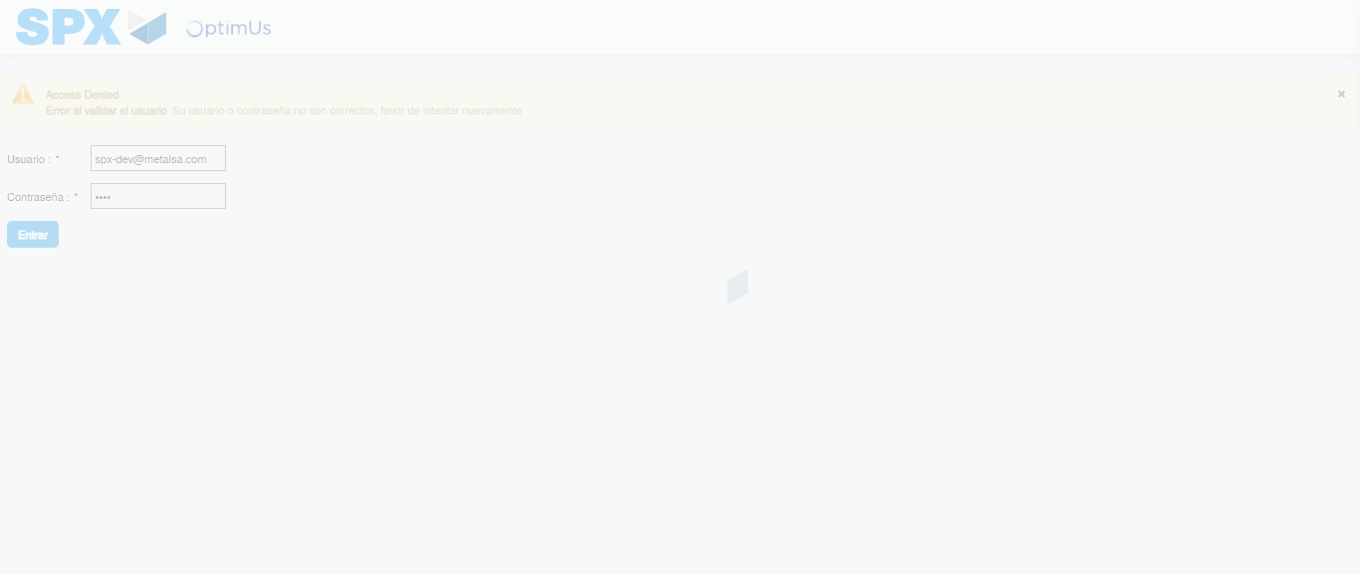Image file-name: QC_Testing-tc001_SPX_Dev5_Crear_Solicitud_Articulo_Almacen-1787930298404

Step 2 - Select to UEN and Access to Request for a New Inventory Item : UEN Correctly selected and Correct access
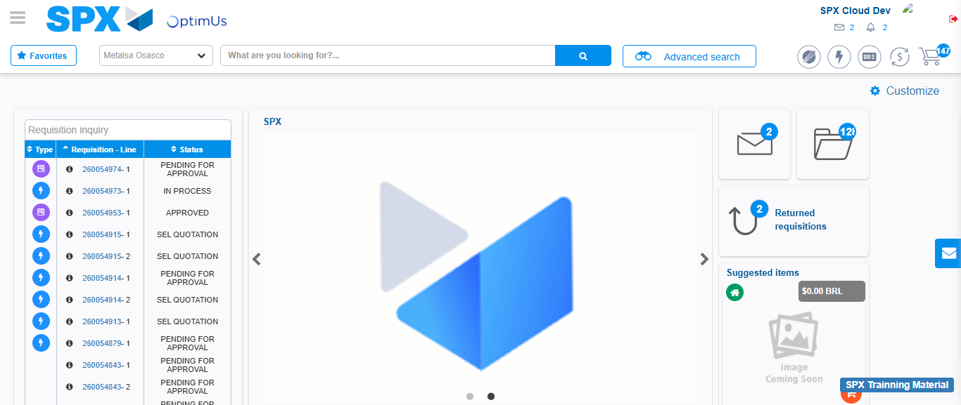Image file-name: QC_Testing-tc001_SPX_Dev5_Crear_Solicitud_Articulo_Almacen-1787930365846

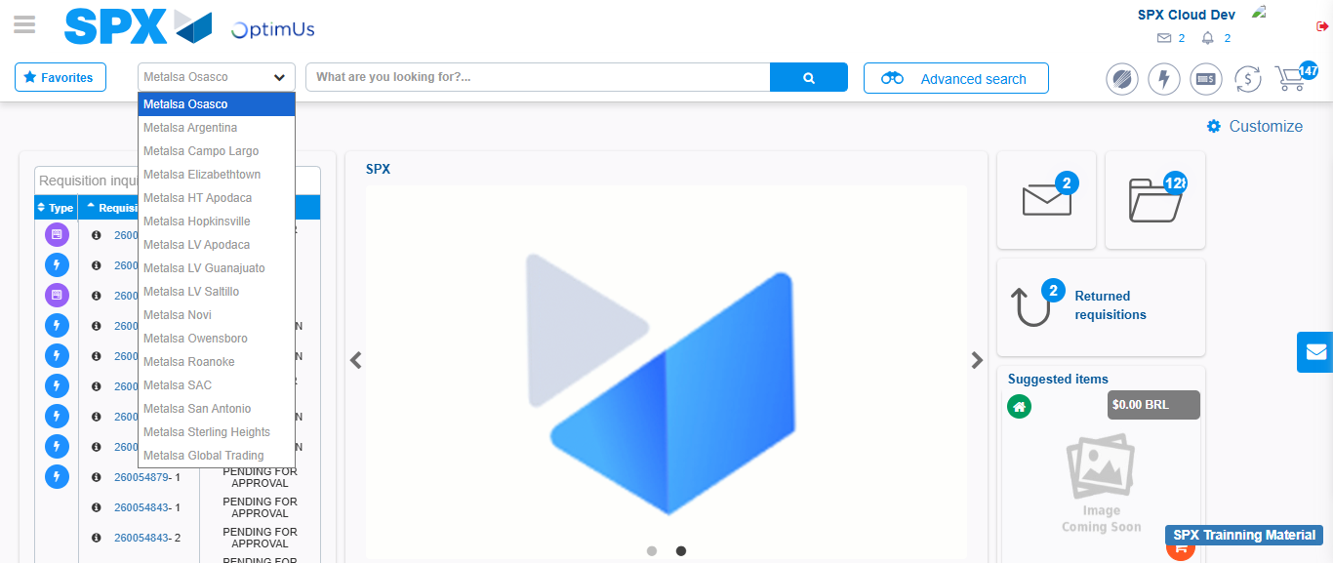Image file-name: QC_Testing-tc001_SPX_Dev5_Crear_Solicitud_Articulo_Almacen-1787930366481

Image file-name: QC_Testing-tc001_SPX_Dev5_Crear_Solicitud_Articulo_Almacen-1787930374276

Step 3 - Select options first section : Options seleted correctly
Image file-name: QC_Testing-tc001_SPX_Dev5_Crear_Solicitud_Articulo_Almacen-1787930374503

Image file-name: QC_Testing-tc001_SPX_Dev5_Crear_Solicitud_Articulo_Almacen-1787930374656

Step 4 - Select options at Screen: Options seleted correctly
Image file-name: QC_Testing-tc001_SPX_Dev5_Crear_Solicitud_Articulo_Almacen-1787930374503

Image file-name: QC_Testing-tc001_SPX_Dev5_Crear_Solicitud_Articulo_Almacen-1787930374656

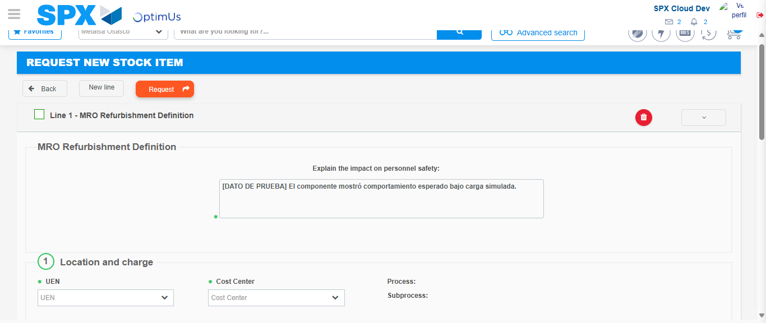Image file-name: QC_Testing-tc001_SPX_Dev5_Crear_Solicitud_Articulo_Almacen-1787930380825

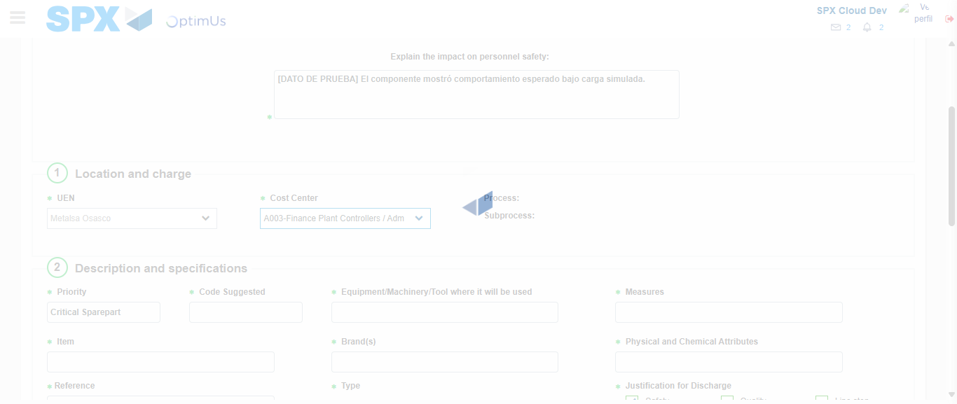Image file-name: QC_Testing-tc001_SPX_Dev5_Crear_Solicitud_Articulo_Almacen-1787930383530

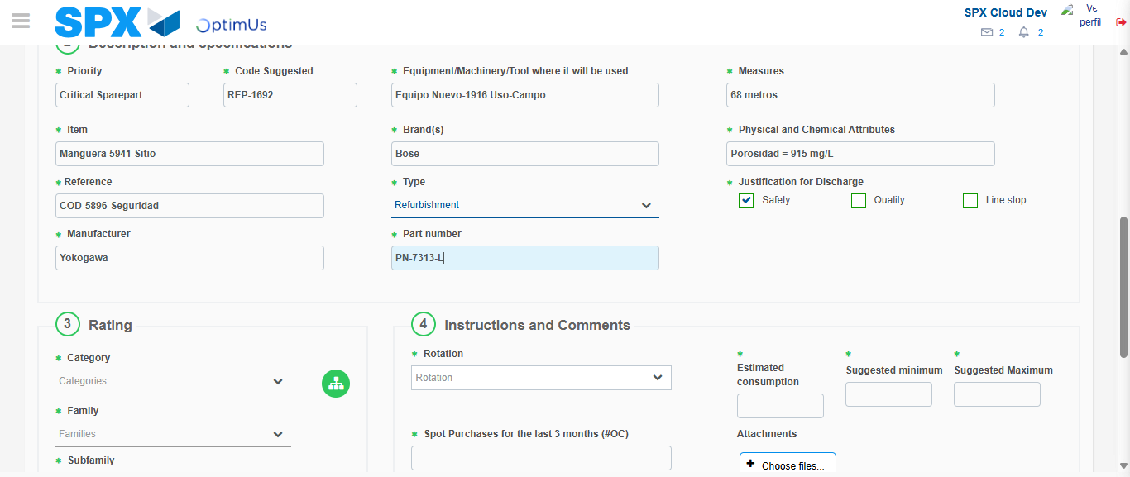Image file-name: QC_Testing-tc001_SPX_Dev5_Crear_Solicitud_Articulo_Almacen-1787930385303

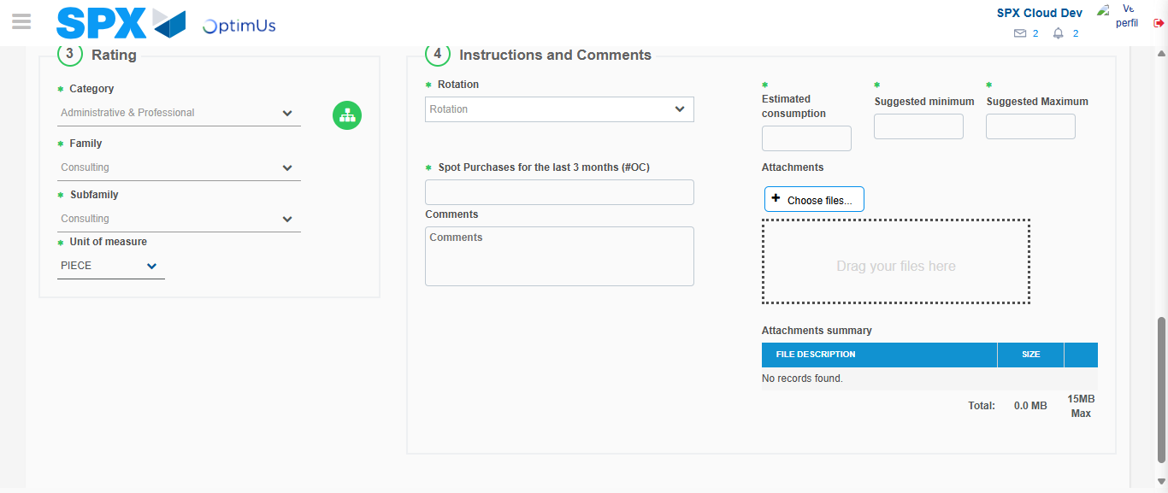Image file-name: QC_Testing-tc001_SPX_Dev5_Crear_Solicitud_Articulo_Almacen-1787930389966

Step 5 - Request New Item : Request Accepted
Image file-name: QC_Testing-tc001_SPX_Dev5_Crear_Solicitud_Articulo_Almacen-1787930365846

Image file-name: QC_Testing-tc001_SPX_Dev5_Crear_Solicitud_Articulo_Almacen-1787930366481

Image file-name: QC_Testing-tc001_SPX_Dev5_Crear_Solicitud_Articulo_Almacen-1787930374276

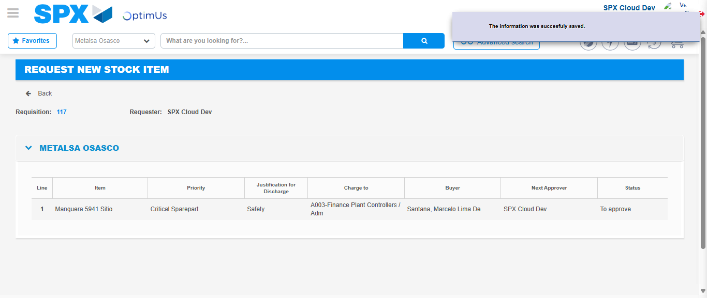Image file-name: QC_Testing-tc001_SPX_Dev5_Crear_Solicitud_Articulo_Almacen-1787930398212

Image file-name: QC_Testing-tc001_SPX_Dev5_Crear_Solicitud_Articulo_Almacen-1787930398379

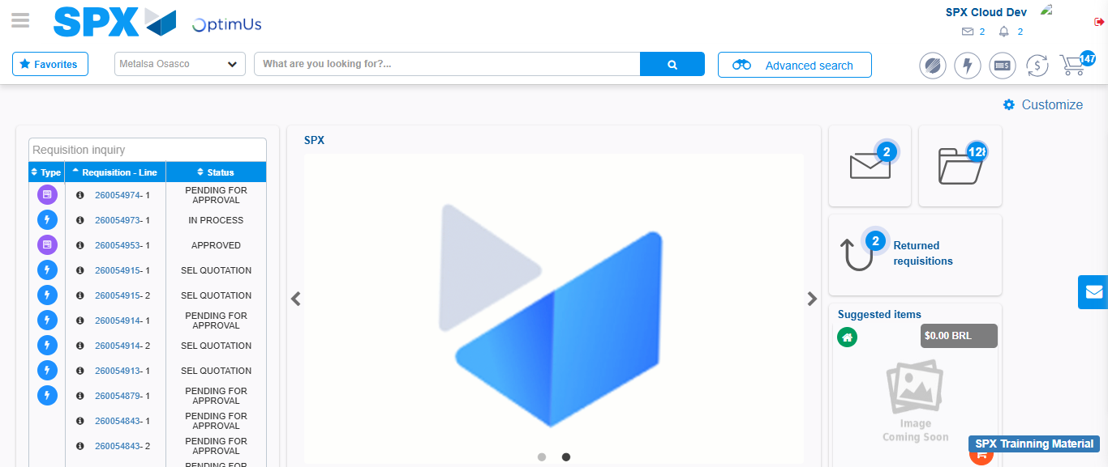Image file-name: QC_Testing-tc001_SPX_Dev5_Crear_Solicitud_Articulo_Almacen-1787930420104

Step 7 - Return to Main Page SPX : Return to Main Page SPX
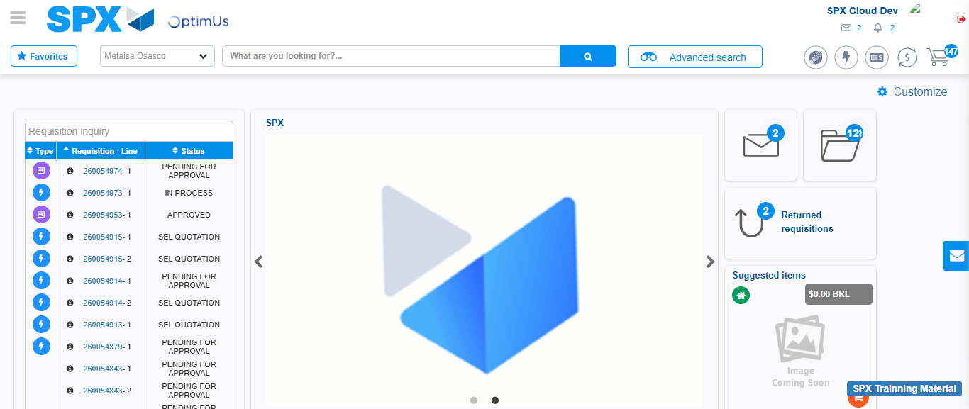Image file-name: QC_Testing-tc001_SPX_Dev5_Crear_Solicitud_Articulo_Almacen-1787930420415

